|  |  |
| --- | --- |
|  |  |
| Vector Quantization |  |
|  |  |
|  | DSAI 325Final Project |
|  | Mohamed Ehab Yousri202201236 |

Vector Quantization for Image Compression

**1-Introduction**

**-Project Objective**: This project aims to implement a Vector Quantization (VQ) algorithm for image compression, with a comparison of results between RGB and YUV color spaces.

**-Dataset**: The dataset consists of three categories of images: "Nature", "Faces", and "Animals," with 15 images in each category, resulting in a total of 45 images. The images are divided into training (30 images) and testing (15 images).

**-Compression Method**: The VQ technique is applied to compress these images using a codebook of 256 vectors, each corresponding to a 2x2 block of pixels.

**2-Methodology**

* 1. **Vector Quantization Process**

**-Codebook Generation**: The codebook is generated using the LBG (Linde-Buzo-Gray) algorithm, where each image is divided into blocks (2x2 pixels), and each block is quantized by the nearest codeword in the codebook.

**-Compression**: After generating the codebook, the images are compressed by replacing each block with the nearest codeword from the codebook.

**-Decompression**: The compressed images are reconstructed by replacing each codeword with the corresponding block from the codebook.

**-Metrics Used**:

* **Mean Squared Error (MSE)**: This metric quantifies the average squared differences between the original and reconstructed images.
* **Compression Ratio**: The ratio of the original image size to the compressed image size, indicating the effectiveness of the compression.
  1. **RGB vs. YUV Color Spaces**

**-RGB Mode**: In the RGB color space, each image is split into three components (Red, Green, Blue). A separate codebook is generated for each component, and all components are processed at full resolution.

**-YUV Mode**: In the YUV color space, images are converted into three components: Y (luminance) and U, V (chrominance). The U and V components are subsampled (4:2:0), reducing their resolution to 50% of the original. This allows for better compression since the human eye is less sensitive to changes in chrominance.

3-Results:

RGB color space:

Sample image:

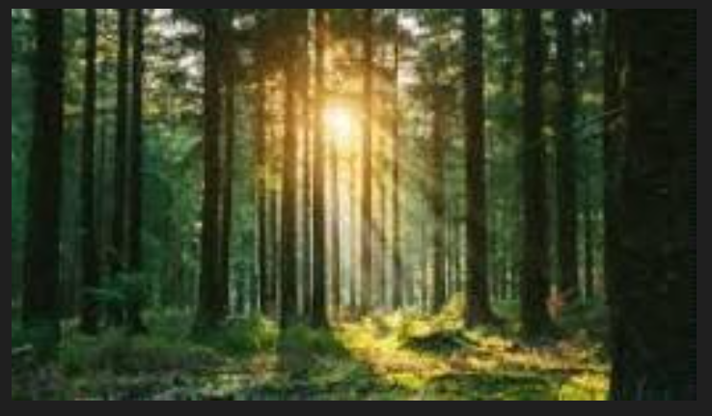

YUV color space:

**Interpretation**:

**-MSE**: Lower MSE indicates better image quality post-compression. The YUV color space generally yields better results than RGB in terms of compression quality, especially for images with more complex chrominance.

**-Compression Ratio**: The YUV mode achieves a higher compression ratio (more compression) compared to RGB. The subsampling of the U and V components reduces data while preserving visual quality.

**-Compression Time**: The compression times are generally faster for the RGB mode, as the process involves handling fewer steps (no subsampling of chrominance).

Average Results:

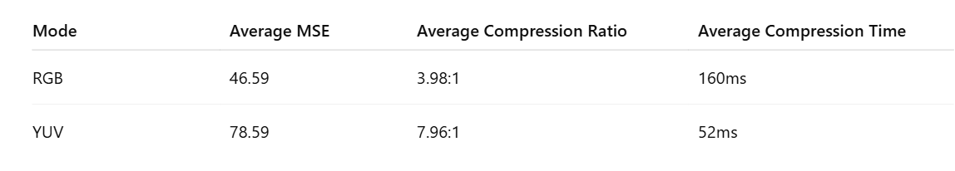

### Discussion

**- RGB Compression**

-In the **RGB mode**, the compression results in a lower compression ratio and higher MSE compared to YUV. This is because each color component (Red, Green, Blue) is processed at full resolution, which increases the amount of data to be processed. While the RGB mode works well for simpler images, it doesn't achieve the same level of compression as YUV.

**-YUV Compression**

-The **YUV mode** achieves a higher compression ratio and lower MSE due to the subsampling of the U and V components, which are less perceptible to the human eye. This mode allows for significant reduction in data without major visual quality loss, making it more efficient for image compression.

**Conclusion**

**-Effectiveness of YUV**: The YUV color space significantly outperforms RGB in terms of compression, as it allows for more efficient use of data by reducing chrominance resolution. This results in higher compression ratios and lower MSE values.

**-Comparison of Techniques**: While RGB is simpler and faster, YUV provides a better compression performance for images with rich color details, especially when used with subsampling techniques on chrominance channels.